

Name : Md Fahim Alam

Batch : 14

SL No : 23

Date : 06.06.24

BRINGING THE WORLD

THE TASTIEST BEVERAGES

Redefining the look, taste and even sound of beverages everyday for more pop.

More fizz. More of that refreshing feeling you need!

The Largest Beverages Company in Bangladesh

**INDEX**

* Our History→ 2-6
* Our Products→ 7-9
* Business Plan→ 9-10
* Our Policies→ 10-12
* Steps to start a Beverage Company→ 12
* Reports→ 12-15
* Rwards & Recognition→ 15-16
* Corporate Social Responsibility→ 16

**OUR HISTORY**

From becoming an exclusive PepsiCo franchisee, Transcom Beverages Limited (TBL) has come a long way. Let’s take a look at our glorious history.

**2000**

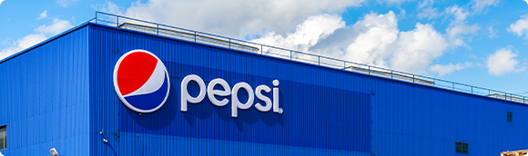

Our journey began in 2000. We became an exclusive PepsiCo franchisee with two plants located in Dhaka and Chattogram, producing 400 BPM (bottle per minute). Since then, our journey has been a story of brilliance, success, and fulfillment.

**2001-03**

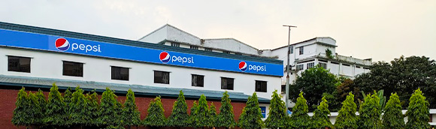

In the years 2001-2003, we added a PET bottle line to our production along with the existing glass return bottles (GRB), which greatly increased convenience and ease of consumption for consumers, distributors and vendors alike.

**2004**

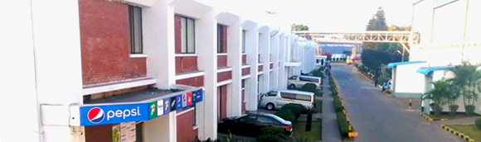

The innovation and expansion of our operations didn’t stop just there. In 2004, we shifted the Tejgaon plant to Konabari. This new plant was equipped with another 630 BPM line and shrink film packaging which greatly increased our production capacity.

**2005**

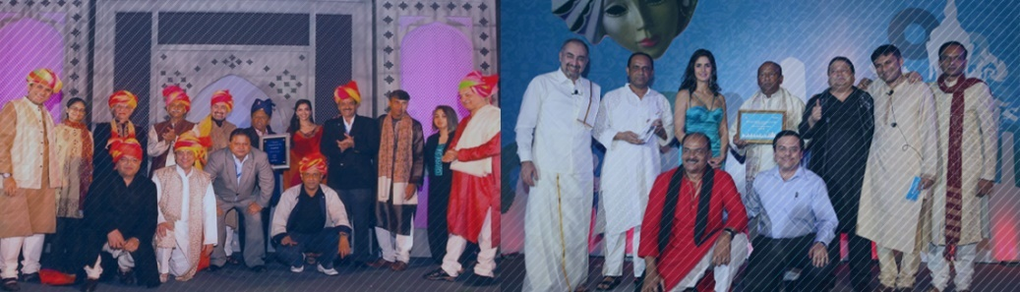

We have always put quality and efficiency above all. And that is how, in 2005, we won the prestigious “Bottle of the Year” award for the very first time from PepsiCo International! Since then, the company has bagged the award for a total of 9 times, in the years 2005, 2008-2014, and 2016.

**2009**

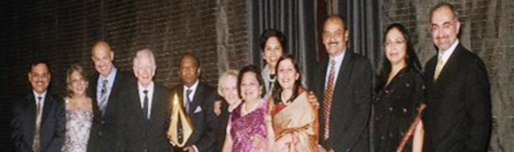

In 2009, TBL’s continuous journey of striving for excellence manifested in the increase of the company’s production capacity yet again to a whopping 1430 BPM. That same year TBL achieved the most prestigious award “International Bottler of the Year” for the first time.

**2013**

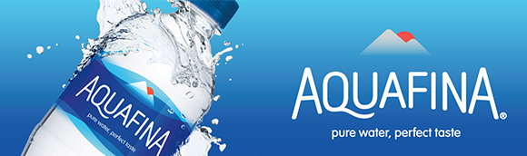

In 2013, the Aquafina production line was first introduced to the Dhaka plant, producing high-quality pure drinking water through a seven-step reverse osmosis purification system.

**2014**

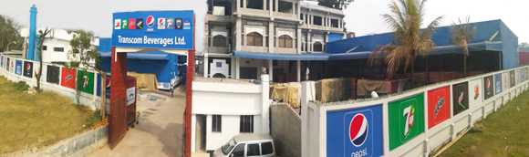

The next year, in 2014, we acquired a plant from Global Beverages and initiated the Bagher Bazar plant operations to meet the growing demand for beverages in Bangladesh. We also added a CAN line here.

**2015**

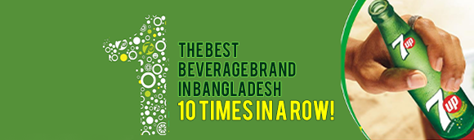

By 2015, we became a stronghold of distributing refreshing beverages to consumers all across the nation. Also, 7up managed to win the Best Beverage Brand award from Bangladesh Brand Forum 10 times in a row.

**2016**

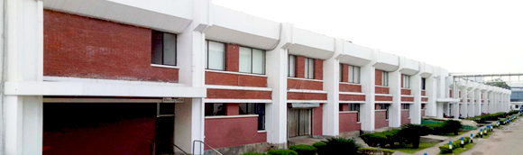

In our mission to become the most efficient beverage company, in 2016, we enhanced the total capacity across three plants. And acquired additional lands to extend the existing Dhaka plant.

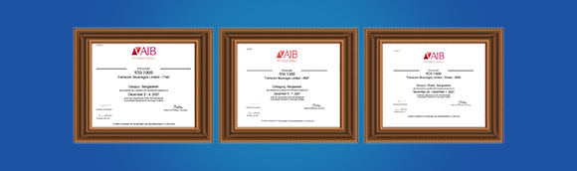

In 2021, TBL celebrated yet another prestigious accomplishment, the AIB Gold Award for ensuring high standards of food safety and compliance! As the nation’s leading beverage manufacturing, marketing and distribution company, at TBL, we believe that this is just the beginning. With our relentless dedication and innovative leadership in the market, we hope to be a shining example of business transformation and sustained growth. And continue to inspire and satisfy our consumers with great taste, quality and refreshment.

**OUR PRODUCTS**

Our entire beverage range is designed to give our consumers more and add refreshment to lives. They are available all around the country and are matched to our local consumers' tastes and preferences.

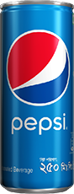

[**Pepsi**](https://www.pepsi.com/)

Our signature cola soft drink, Pepsi now comes with more fizz and more refreshment.

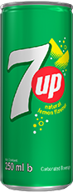

[**7up**](https://www.7up.com/en)

Enjoy the refreshing taste of 7UP, our iconic lemon lime drink.

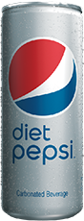

[**Pepsi Diet**](https://www.pepsi.com/en-us/#!products/diet-pepsi)

Pepsi Diet gives you all the refreshments with zero sugar and zero calories.

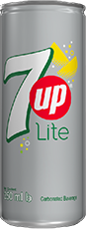

[**7up Lite**](https://gofresh.com.bd/product/coca-cola-diet-no-sugar-250ml/)

The same refreshing lemon lime flavor, minus the sugar.

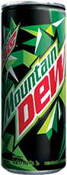

[**Mountain Dew**](https://contact.pepsico.com/mtndew)

Experience the thrilling refreshment of Mountain Dew with its one of a kind taste.

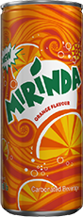

[**Mirinda**](https://www.pepsi.ps/products/mirinda)

A fun-filled orange drink with a delicious tangy zing!

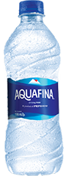

[**Aquafina**](https://en.wikipedia.org/wiki/Aquafina)

Enjoy the perfect taste of purified water, with Aquafina’s reverse osmosis purification system.

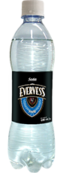

[**Evervess**](https://store.quality.mu/product/drinks-and-juices/soft-drinks/evervess-soda-500x12/)

A refreshing and bubbly beverage, ideal as a mixer or simply served over ice.

**Business Plan**

TBL aims to provide refreshment for inspirational consumer moments and reflect this on the company’s accelerated business growth while upholding the company’s integrity, ethical practices and excellence in the business operations and ensure sustainable growth in Bangladesh.

As largest CSD Beverages company of the country, our mission is to provide consumers delicious, healthy, affordable and convenient beverages by keeping highest market share in the segment.

We plan to deliver sustainable growth in Bangladesh and be the dominant Beverages Company; delighting and nourishing every Bangladeshi, by best meeting their everyday beverages needs and delivering performance with purpose.

* **Business policy**
* Use Brand Name
* Training Help
* Marketing Help
* Knowledge Sharing
* Technical Help
* **Marketing Policy**
* Advdertising
* Promotion
* Public Relation
* **Production Strategy**
* Forcasting of production based on order
* Four step production process
* Number of production plants
* Production and distribution diagram

**Steps to start a Beverage Company**

**Yearly Report 2023**

|  |  |  |  |
| --- | --- | --- | --- |
| **Month** | **Expenses** | **Sales** | **Profit** |
| January | 9288500 | 8750000 | -538500 |
| February | 9744300 | 9920000 | 175700 |
| March | 8904700 | 10000000 | 1095300 |
| April | 7345200 | 7957400 | 612200 |
| May | 8987000 | 9876500 | 889500 |
| June | 5215400 | 5164500 | -50900 |
| July | 9976500 | 11543600 | 1567100 |
| August | 7976700 | 8087900 | 111200 |
| September | 9879000 | 9969800 | 90800 |
| October | 6234800 | 7024000 | 789200 |
| November | 4534800 | 4809300 | 274500 |
| December | 8348700 | 8834800 | 486100 |

Monthly Report 2024

(1st three months)



**Rewards and Recognition**

Transcom Beverages Limited has won various honors and has been acknowledged both locally and globally throughout the years. These accomplishments have inspired millions of individuals and have resulted in strong messages, all while maintaining the company's ethical, efficient, and productive corporate operations.

* Bottle of the year (2009 & 2016)
* Best Plant Team (2014)
* PepsiCo AMENA Silver Food Safety Award (2016)
* Celeb Bradham Bronze Award (2016 & 2018)
* Celeb Bradham Silver Award (2017)
* Chairman’s Circle of Champions (2017 & 2018)
* Best of The Best Platinum Award

Corporate Social Responsibility

As a company, we believe in sustainable living and giving more to lives. That’s why, besides our business, we take actions on the issues affecting our world and try to make a difference in people’s lives.

* Raised Funds for Covid-19
* PepsiCo Positive

(We’re charting a new course to drive positive action for the planet and people)

* We’re working to source our crops & ingredients in ways that restore the earth and strengthen farming communities.
* We’re inspiring people through our brands to make choices that create more smiles for them and the planet.



Corporate Headquarters:

Gulshan Tower (9th Floor), Plot #31, Road #53, Gulshan North CA, Dhaka – 1212

Phone: 02-8834586, 58810573-6, 8832559-61

Email: [info@tbl.transcombd.com](mailto:info@tbl.transcombd.com)

Factory:

Transcom Beverages Ltd. - Dhaka Plant, Telirchala, Mouchak, Kaliakoir, Gazipur

Phone: 880-2-9297912-6

Fax: 880-2-9297917

→